# Game Engines

## Task 2

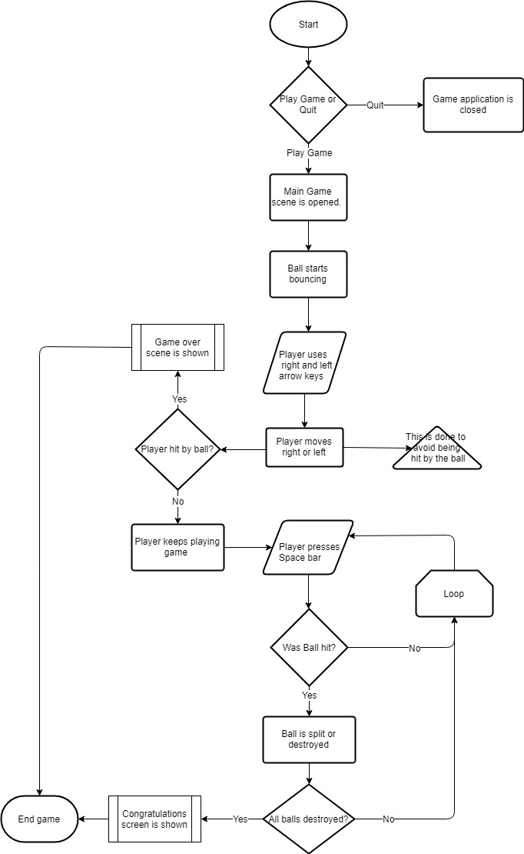

**Flowchart**

**Target Device**

The target device is for a PC/Laptop only. The reason for this is because it would be a bit hard to try and destroy the balls while moving and avoiding getting hit on a touch screen. It just isn’t ideal and people would get annoyed.

**Game Mechanics and Game Objectives**

The game mechanics of the game are relatively simple and straightforward. The player simply needs to press Left or Right arrow key (While always avoiding being hit by balls) and press Space bar to destroy the balls in order to win.

**Visual assets**



Background for game

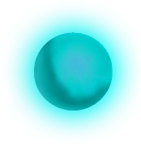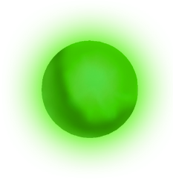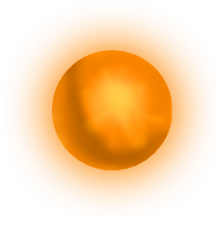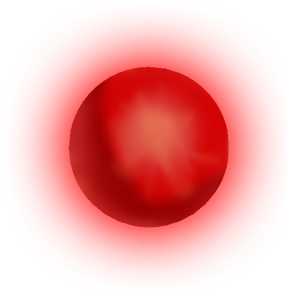

The objective/enemy (balls)

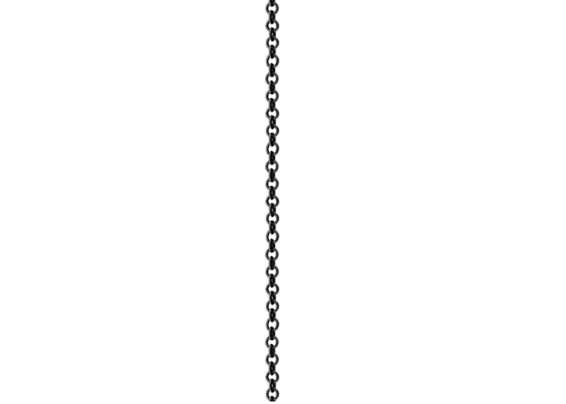 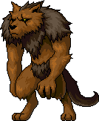

The player

Chain/Spike/Ball Destroyer

**UI elements and Game Scenes**

When the player first enters the game, he is shown a start (home) screen and will be given 2 Buttons and/or Text components (still to be decided on which to use), which when clicked on by the left mouse button, will carry out an action depending on which element the player clicked. The player can either start the game by clicking “PLAY” or exit the application by clicking “QUIT”.

When clicking “PLAY”, the player is taken into the game and will be able to play. If the player either wins the game by destroying all balls, or gets hits by a ball, then the winning game or lost game screen will pop up, and the player would be able to either click on “PLAY AGAIN”, or go to the start (home) screen by clicking “HOME”.

The screens and scenes would look similar to the images shown below:

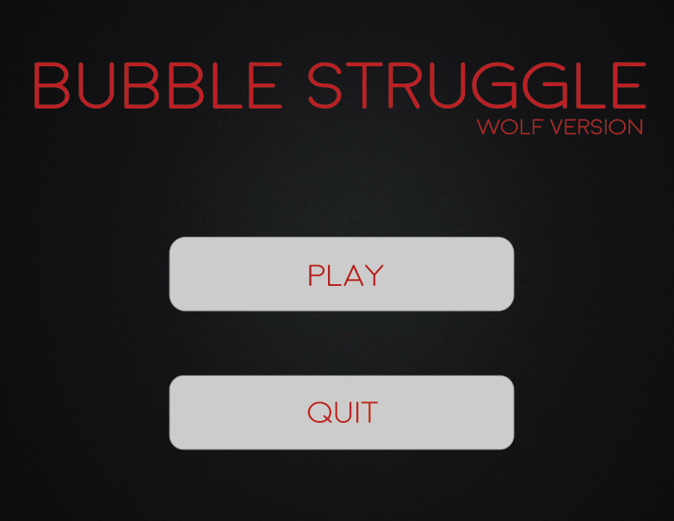

Start Screen

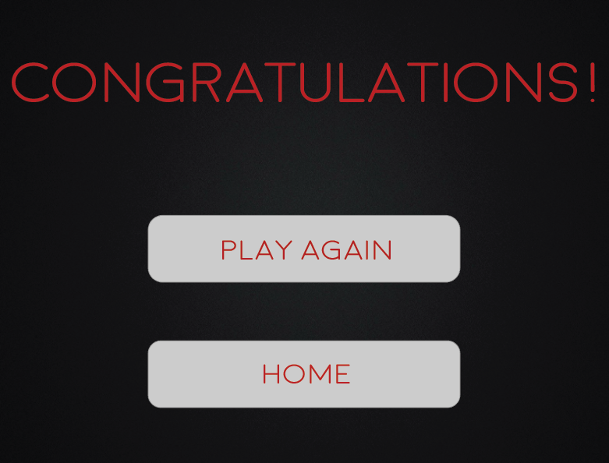

Winning Game Screen

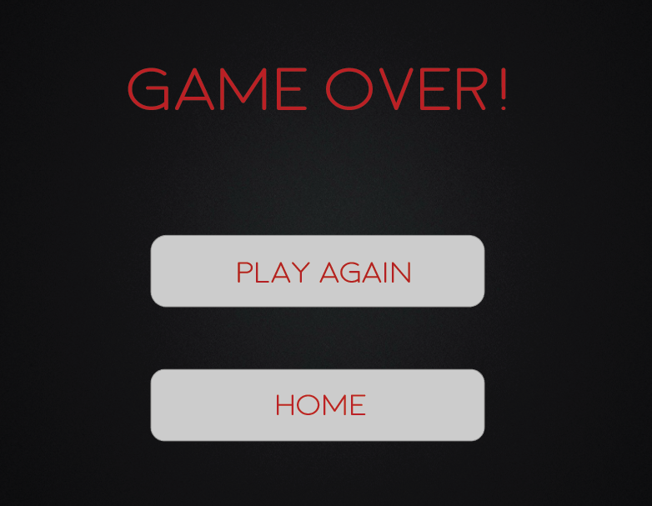

Lost Game Screen

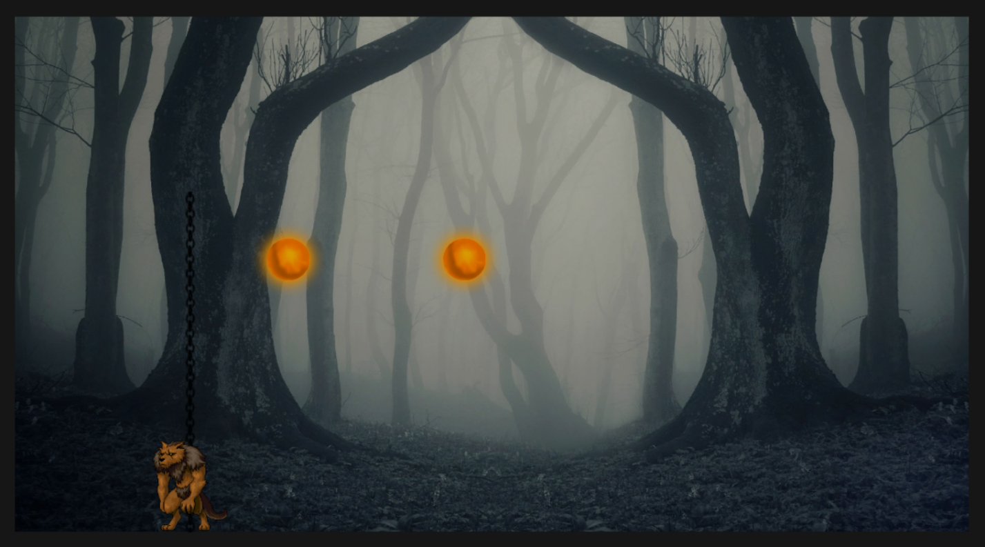

Main Game Scene